Self Pay Patient Registration
Reason for Visit:
Please Circle: LEFT side RIGHT side Bilateral

__________________________________________________________________________________________________
__________________________________________________________________________________________________

First Name: ________________________ MI: ______ Last Name: _______________________________________
Mailing Address: ______________________________ City: ____________________ ST: ____ Zip: ________________
Patient Gender: _____________ Marital Status: Married Single Widowed Child
Patient DOB: ________________ Patient Social Security Number: _________________________
Home Phone: ________________ Work Phone: _____________________ Cell Phone: _____________________
Email Address: _____________________________________________________________________________________
Primary Doctor: _________________________________ Primary Doctor Phone: _______________________________

EMERGENCY CONTACT
Name:__________________________________ Phone:_______________ Relationship: _____________

Employment/School Information
Employment Status: Full Time Part Time Retired Student Disabled Not working due to Injury
Employer/School: _______________________________ Job Title: ________________Phone: ____________________
Driver's License #: _____________________________ Driver's License State: ________________

Signature of Patient: _______________________________________ Date:

Guardian Information
Name of Guardian: _______________________________ Relationship: ________________________
Mailing Address: ____________________________________________________________________________
Phone Number: __________________ Email Address:_____________________________________________

Signature of Guardian: ____________________________________________ Date:

SELF PAY POLICY

When a patient accepts services from Harrington, PT and does not present an insurance policy for MHPT to bill, the patient's account is considered SELF PAY.
Our office policy at HPT for Self Pay accounts is as follows:
If a patient chooses to pay in full at time of service, we offer a 20% discount.
If a patient cannot afford to pay in full at each visit then the following applies:
The patient will be required to pay $150.00 at their initial appointment and $100.00 at each follow up visit after that.
Statements will be sent out monthly to each patient.
Any remaining balance due becomes patient's full responsibility to pay. Payment is required upon receipt of statement.
To avoid collection proceedings, consistent monthly payments are required.
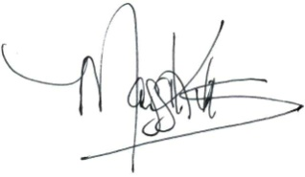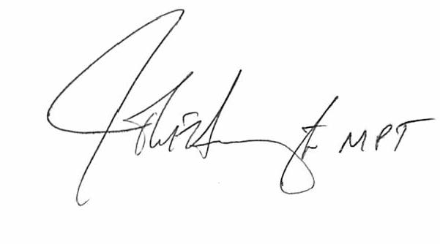
_________________________________ ________________________________
Maggi Kuxhaus John Harrington, PT
Healthcare Reimbursement Specialist President/Owner

Patient Name:
DOB:
File Number:

_________________________________ ________________________________
Patient Signature/Print Name if Guardian Guardian Signature
Date: Date:

Assignment and Release
I hereby authorize my insurance benefits to be paid directly to the Provider. I also authorize the Provider to release any information required by the insurer for said payment. I am financially responsible for non-covered service. I further authorize Harrington Physical Therapy, PC to access any part of my records from my physician's office for continuity of care purposes and/or for the adjudication of all claims relating to payment of service. Records may be accessed in hard copy or by computer. I fully understand that only staff with a "need to know" based upon their job functions will have access to my records.

It is understood that my medical record and those acquired from other facilities with my permission, will be held in strict confidence and will not be release to any other party without my expressed written authorization.

I understand that should I default on payment of my account, and collection agency service be required, all cost of collections, including attorney fees will be added to the balance on my account.
Medical Photography or Videoing of Reason for Visit
I hereby authorize Harrington Physical Therapy, PC to photograph me and to store those photographs in my medical chart as part of my evaluation and/or treatment. I understand that said photographs will not be used for any purposes other than medical care and will not be release to any party other than those authorized by myself.

Initial No If You Do Not Want This: No: _____________
Notice of Privacy Practices
Examples of Disclosure for Treatment, Payment and Health Operations

We will use your health information for treatment. For example: Information obtained by a nurse, physician, or other member of your healthcare team will be recorded in your record and used to determine the course of treatment that should work best for you. Your physician will document in your record his/her expectations of the members or your healthcare team. Members of your healthcare team will then record the actions they took and their observation. In that way, the physician will know how you are responding to treatment.
We will use your health information for payment. For example: A bill may be sent to you or a third-party payer. The information on or accompanying the bill may include information that identifies you, as well as your diagnosis, procedures, and supplies used.
We will use your health information for regular health operations. For example: Members of the medical staff, the risk or quality improvement manager, or members of the quality improvement team may use information in your health record to assess the care and outcomes in your case and others like it. This information will then be used in an effort to continually improve the quality and effectiveness of the healthcare and service we provide. Business associates: There are some service provided in our organization through contacts with business associates. Examples include physician service in the emergency department and radiology, certain laboratory test your health record. When these services are contracted, we may disclose your health information to your business associate so that they can perform the job we've asked them to do and bill you or your third-party payer for services rendered. To protect your health information, however, we require the business associate to appropriately safeguard your information.
WRITTEN ACKNOWLEDGEMENT
I acknowledge that I have reviewed the Notice of Privacy Practices which provides a description of information uses and disclosures. I understand that I have the right to request restrictions as to how my health information may be used or disclosed, that the organization is not required to agree to the restrictions I request.

X_______________________________________________
Signature of Patient or Legal Representative Date

X_______________________________________________
Witness Date

